**London riots: the underclass lashes out**

(The Daily Telegraph – August 8th 2011)

## London's rioters are the products of a crumbling nation, and an indifferent political class that has turned its back on them.

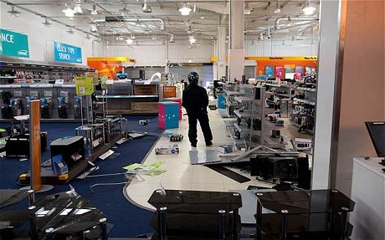

No one seemed surprised. Not the hooded teenagers fleeing home at dawn. Not Ken and Tony, who used to live in Tottenham and had returned to stand vigil over the missiles and torched cars littering an urban war zone. Tony claimed to have seen the whole thing coming. “This was always going to happen,” he said.

The police shot a black guy in suspicious circumstances. Feral kids with no jobs ran amok. To Tony’s mind, this was a riot waiting for an excuse. In the hangover of the violence that spread through London, the uprisings seemed both inevitable and unthinkable. Over a few days in which attacks became a contagion the capital city of an advanced nation has reverted to a Hobbesian dystopia of chaos and brutality.

“In the evening there is fear, and in the morning they are gone. This is the fate of those who take our goods, and the reward of those who violently take our property.” Isaiah 17:14. No such Old Testament fate awaited the pillagers of N18, strolling away from 21st-century megastores with a looted haul of iPod accessories and designer trainers.

This is the most arcane of uprisings and the most modern. Its participants, marshalled by Twitter, are protagonists in a sinister flipside to the Arab Spring. The Tottenham summer, featuring children as young as seven, is an assault not on a regime of tyranny but on the established order of a benign democracy. One question now hangs over London’s battle-torn high streets. How could this ever happen?

Among several obvious answers, one is a failure of policing. The evidence so far points to more ignominy for the rudderless Met, as doubts emerge over whether Mark Duggan, whose death inspired the initial riots, fired at police. The stonewalling of Mr Duggan’s family precipitated the crisis, and the absence of officers to intervene in an orgy of looting led to a breakdown of order suggestive of the lawless badlands of a failing state.

1. Who is the folk devil in this article? __________________________________________________________
2. Underline the words and phrases in the article that show this.
3. Explain how this could cause a moral panic: